**Problem 4**

4 (a) No, it cannot be linearly separable for the XOR, in the original feature space.

4 (b) y = wT  , we can calculate the wT by matrix multiplication of XTY as [0,0,0,1], also by intuition we can see x1x2 represent the y completely and other terms don’t contribute much and can be eliminated.

wT= [0,0,0,1]

|  |  |  |  |  |
| --- | --- | --- | --- | --- |
| Y | 1 | X1 | X2 | x1x2 |
| **1** | 1 | 1 | 1 | **1** |
| **-1** | 1 | 1 | -1 | **-1** |
| **-1** | 1 | -1 | 1 | **-1** |
| **1** | 1 | -1 | -1 | **1** |

4 (c) We can draw the opposite class points near the current point and then it will be difficult to separate the space linearly in the feature space defined as below.

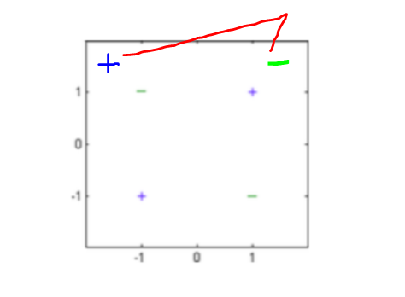

4 (d) K(x,x) corresponds to Kernel function given by the inner product of feature vector in another vector space.

$K\left(x,x\right)=ϕ\left(x\right)ϕ^{'}\left(x\right)$

= [1, x1, x2, x1x2] ${\left[1,x1^{'},x2^{'},x1^{'}x2^{'}\right]}^{T}$

= $1+x1.x1^{'}+x2.x2^{'}+x1.x2.x1^{'}. x2^{'}$

**Problem 5**

Consider the solution min(w,b) =

5 (a) For large values of C $→ ∞$, we are penalizing less with (1/ $λ$) but shrinking the margin heavily. But we are penalizing more for misclassified points, and the decision boundary will separate the data better as much as possible. Please find the figure below.

5 (b) For C -> 0, we not penalizing more for misclassified and maximizing the margins, we can have some misclassified points. Please find the drawing below.

5 (c) As the sensor data is not reliable and we have to account for the errors or misclassification, we can use C approaching 0 as in 5(b) as better classification.

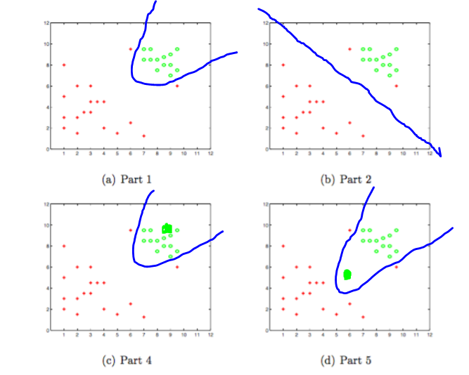

5 (d) If the point lies close to the positive examples, even large C won’t change the decision boundary as shown above.

5 (e) If we add a point closer to the opposite classes, which will result in misclassification with the initial approach can result in affecting the decision boundary learned for large values of C as shown in the figure above.

**Programming**

6.1 (a) 100 datasets with 10 samples - Computed the bias2 and variance for the various g(x) function, results as follows.

|  |  |  |  |
| --- | --- | --- | --- |
|  | MSE | BIAS2 | VAR |
| g1 | 0.484623 | 0.470979 | 0.0 |
| g2 | 0.343810 | 0.366203 | 0.034857 |
| g3 | 0.275135 | 0.369681 | 0.10187 |
| g4 | 0.007334 | 0.169967 | 0.173902 |
| g5 | 0.006209 | 0.16999 | 0.174956 |
| g6 | 0.004937 | 0.169984 | 0.175693 |

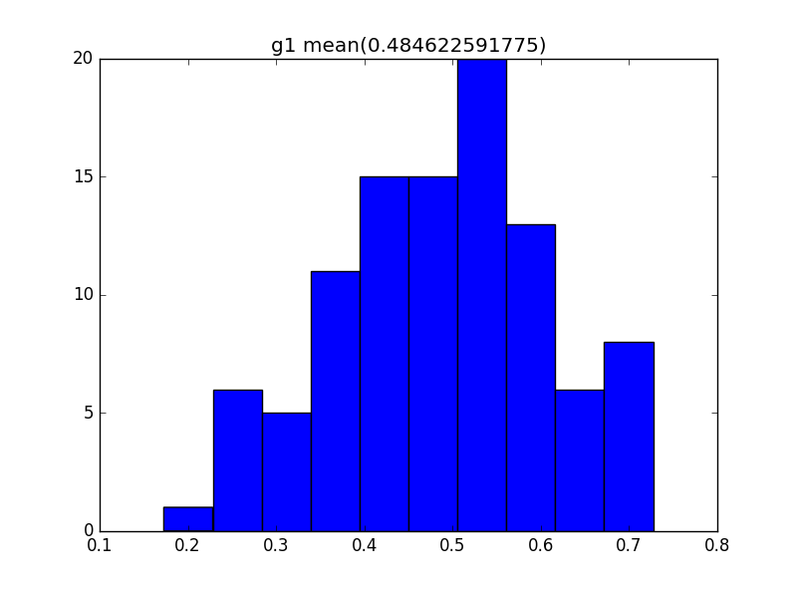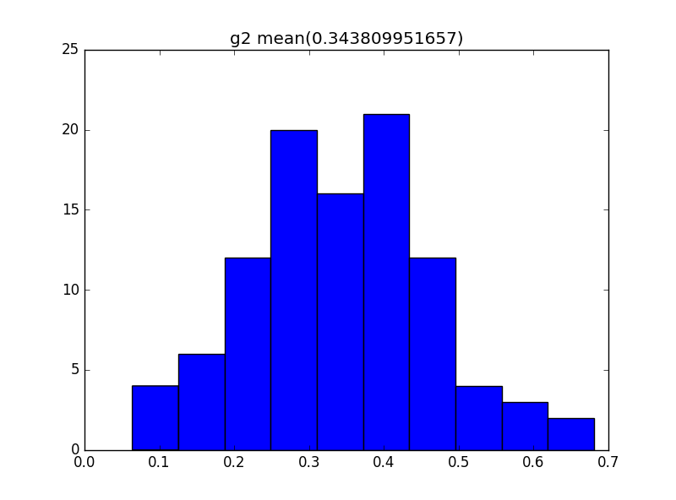

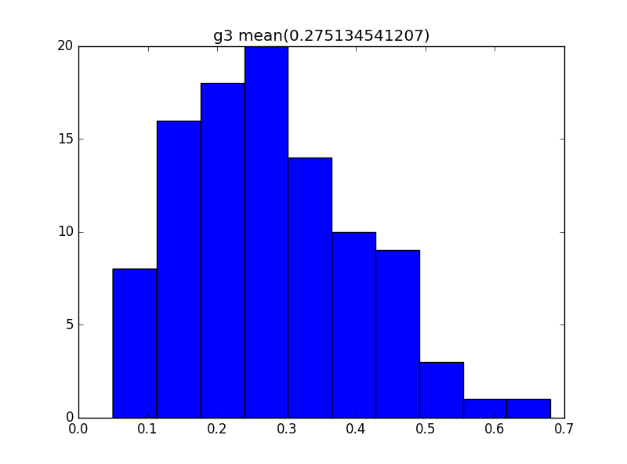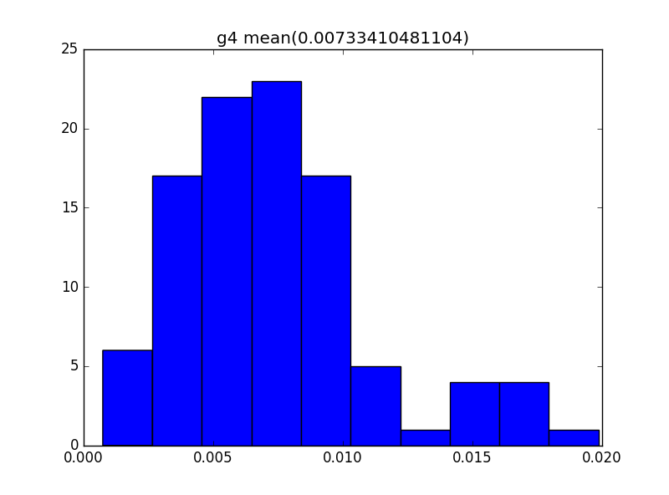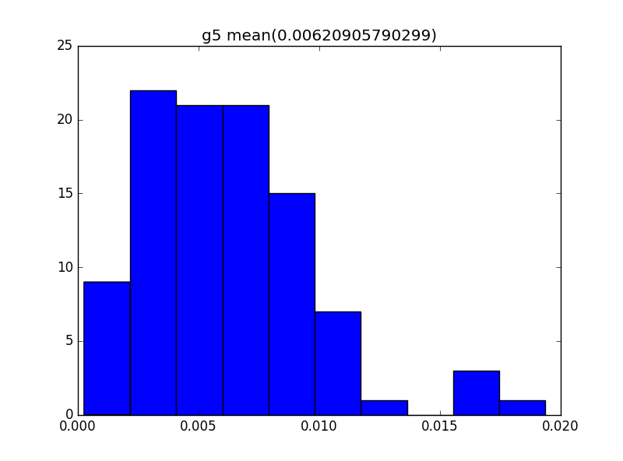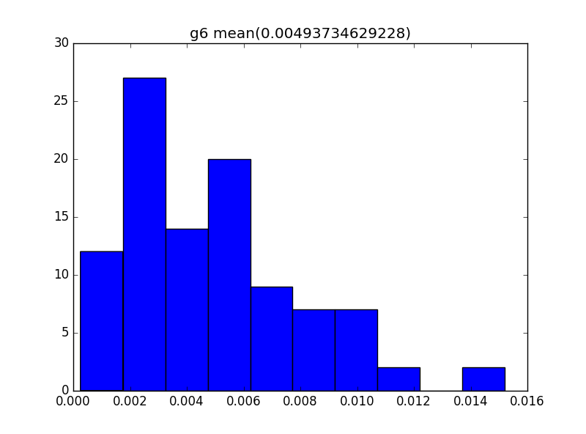

6 .1(b) 100 datasets with 100 samples - computed bias^2 and variance as follows:

|  |  |  |  |
| --- | --- | --- | --- |
|  | MSE | BIAS2 | VAR |
| g1 | 0.480079 | 0.468741 | 0.0 |
| g2 | 0.366036 | 0.358126 | 0.003396 |
| g3 | 0.361132 | 0.358591 | 0.008276 |
| g4 | 0.009472 | 0.018377 | 0.01897 |
| g5 | 0.009363 | 0.018377 | 0.018984 |
| g6 | 0.009241 | 0.018379 | 0.018996 |

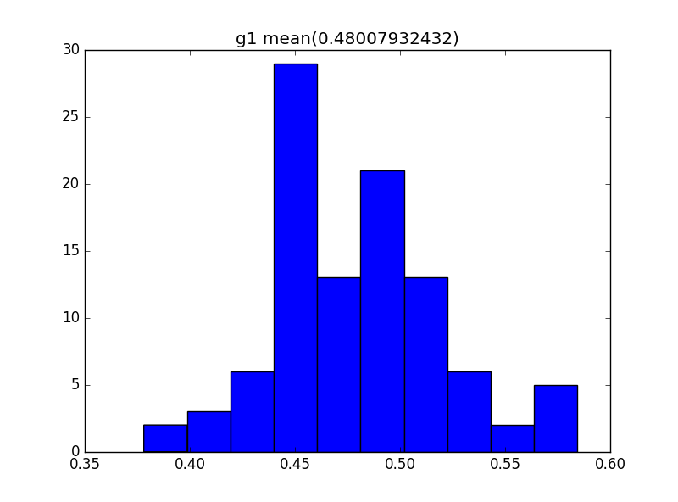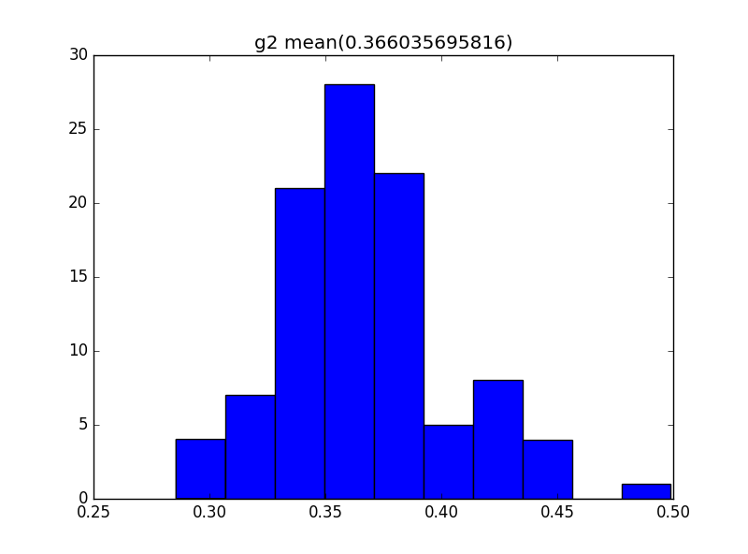

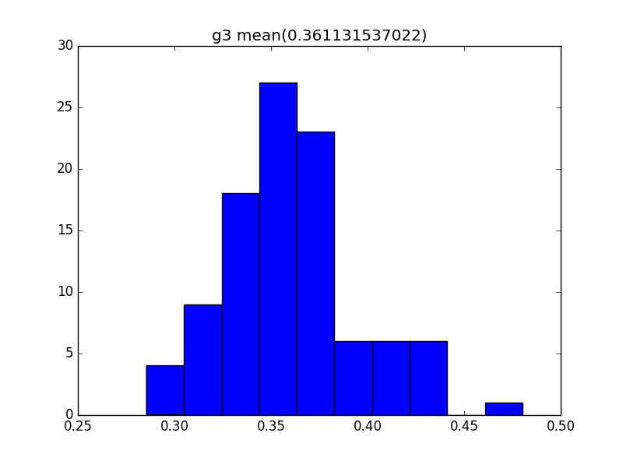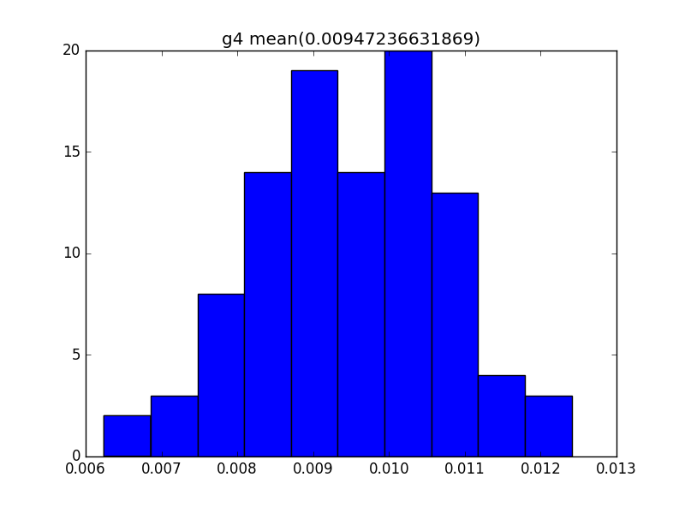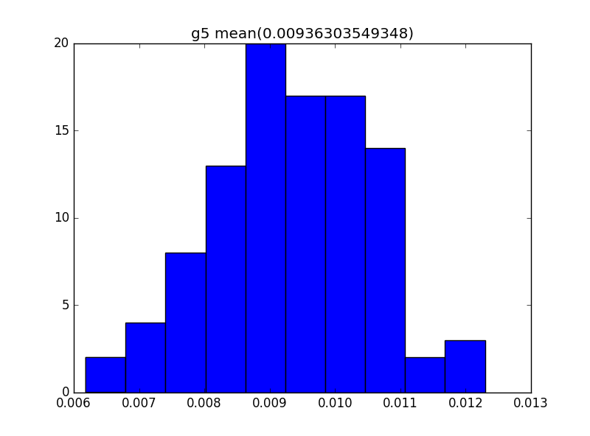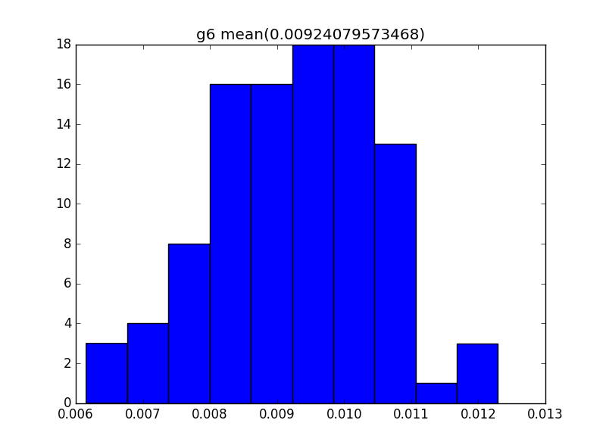

6 1.(c) It can be observed that with the increase in the model complexity the squared bias decreases and the variance increases and the mean squared error decreases, as we try to fit the model better for each point.

The impact of sample size increase was seen more significant on the variance, with decrease in the variance for larger sample size, as 6(b) compared to 6(a). Though bias also varied with larger sample size for the corresponding hypothesizes, but not much increase. Otherwise, the bias and variance followed the tradeoff pattern same as with the complexity. Small sample size is source for the variance.

6 1.(d)

|  |  |  |  |
| --- | --- | --- | --- |
| Lambda | MSE | BIAS2 | VAR |
| 0.001 | 0.000206 | 0.021334 | 0.02142 |
| 0.003 | 0.000184 | 0.020867 | 0.021087 |
| 0.01 | 0.000202 | 0.019087 | 0.019272 |
| 0.03 | 0.000184 | 0.021346 | 0.02148 |
| 0.1 | 0.000224 | 0.021106 | 0.021198 |
| 0.3 | 0.000608 | 0.023374 | 0.022039 |
| 1 | 0.003937 | 0.024233 | 0.017955 |

It is observed that as $λ$ the increases, the variance seems to be decreasing along with the bias increases. With higher $λ$ we try to give large penalty and hence the coefficient tend to be close to zero, at the cost of the bias increase. With the regularization we are trying to reduce the variance and thus the mean squared error, this is typically useful when we have more number of parameters than the number of samples.

**6.2 LIBSVM**

**Linear LibSVM with 3-fold CV**

Training time =22.6619999409 seconds

Cross Validation Accuracy :-

|  |  |
| --- | --- |
| C | CV Accuracy |
| {0.000244140625 | 55.75 |
| 0.000977 | 88.5 |
| 4 | 94.4 |
| 0.25 | 93.8 |
| 1 | 93.85 |
| 16 | 94.55 |
| 0.003906 | 91.25 |
| 0.015625 | 92.55 |
| 0.0625 | 94.1 |

**Polynomial LibSVM with 3 fold**

Training time = 160.46600008 seconds

Cross Validation Accuracy :-

|  |  |  |
| --- | --- | --- |
| Degree | C | CV accuracy |
| 1 | 0.015625 | 55.75 |
| 1 | 0.0625 | 89.5 |
| 1 | 0.25 | 91.15 |
| 1 | 1 | 93.35 |
| 1 | 4 | 94.15 |
| 1 | 16 | 94.4 |
| 1 | 64 | 94 |
| 1 | 256 | 94.95 |
| 1 | 1024 | 94.5 |
| 1 | 4096 | 95 |
| 1 | 16384 | 94.35 |
| 2 | 0.015625 | 55.75 |
| 2 | 0.0625 | 88.75 |
| 2 | 0.25 | 91.85 |
| 2 | 1 | 93.05 |
| 2 | 4 | 94.6 |
| 2 | 16 | 95.8 |
| 2 | 64 | 97 |
| 2 | 256 | 96.3 |
| 2 | 1024 | 96.25 |
| 2 | 4096 | 96 |
| 2 | 16384 | 95.9 |
| 3 | 0.015625 | 55.75 |
| 3 | 0.0625 | 72.15 |
| 3 | 0.25 | 91.65 |
| 3 | 1 | 92.95 |
| 3 | 4 | 95.25 |
| 3 | 16 | 96.05 |
| 3 | 64 | 96.85 |
| 3 | 256 | 96.85 |
| 3 | 1024 | 96.55 |
| 3 | 4096 | 96.95 |
| 3 | 16384 | 96.25 |

**RBF LibSVM 3-fold**

training time = 185.242000103 seconds

Cross Validation Accuracy :-

|  |  |  |
| --- | --- | --- |
| Gamma | C | CV accuracy |
| 6.10E-05 | 0.015625 | 55.75 |
| 6.10E-05 | 0.0625 | 55.75 |
| 6.10E-05 | 0.25 | 55.75 |
| 6.10E-05 | 1 | 55.75 |
| 6.10E-05 | 4 | 67.8 |
| 6.10E-05 | 16 | 91 |
| 6.10E-05 | 64 | 91.35 |
| 6.10E-05 | 256 | 93.85 |
| 6.10E-05 | 1024 | 94.35 |
| 6.10E-05 | 4096 | 94.6 |
| 6.10E-05 | 16384 | 94.75 |
| 0.000244141 | 0.015625 | 55.75 |
| 0.000244141 | 0.0625 | 55.75 |
| 0.000244141 | 0.25 | 55.75 |
| 0.000244141 | 1 | 67.1 |
| 0.000244141 | 4 | 90.6 |
| 0.000244141 | 16 | 91.25 |
| 0.000244141 | 64 | 93.4 |
| 0.000244141 | 256 | 94.35 |
| 0.000244141 | 1024 | 94.45 |
| 0.000244141 | 4096 | 94.4 |
| 0.000244141 | 16384 | 94.55 |
| 0.000976563 | 0.015625 | 55.75 |
| 0.000976563 | 0.0625 | 55.75 |
| 0.000976563 | 0.25 | 67 |
| 0.000976563 | 1 | 90.55 |
| 0.000976563 | 4 | 91.3 |
| 0.000976563 | 16 | 93.95 |
| 0.000976563 | 64 | 94.3 |
| 0.000976563 | 256 | 94.8 |
| 0.000976563 | 1024 | 94.65 |
| 0.000976563 | 4096 | 95.25 |
| 0.000976563 | 16384 | 96.6 |
| 0.00390625 | 0.015625 | 55.75 |
| 0.00390625 | 0.0625 | 64.25 |
| 0.00390625 | 0.25 | 90.8 |
| 0.00390625 | 1 | 91.15 |
| 0.00390625 | 4 | 93.35 |
| 0.00390625 | 16 | 94.7 |
| 0.00390625 | 64 | 94.95 |
| 0.00390625 | 256 | 95.65 |
| 0.00390625 | 1024 | 96.25 |
| 0.00390625 | 4096 | 97 |
| 0.00390625 | 16384 | 97 |
| 0.015625 | 0.015625 | 56.1 |
| 0.015625 | 0.0625 | 90.4 |
| 0.015625 | 0.25 | 91.2 |
| 0.015625 | 1 | 93.65 |
| 0.015625 | 4 | 94.45 |
| 0.015625 | 16 | 96.15 |
| 0.015625 | 64 | 96.7 |
| 0.015625 | 256 | 96.8 |
| 0.015625 | 1024 | 96.45 |
| 0.015625 | 4096 | 96.45 |
| 0.015625 | 16384 | 96.5 |
| 0.0625 | 0.015625 | 87.6 |
| 0.0625 | 0.0625 | 91.85 |
| 0.0625 | 0.25 | 93 |
| 0.0625 | 1 | 95.75 |
| 0.0625 | 4 | 97.1 |
| 0.0625 | 16 | 97 |
| 0.0625 | 64 | 96.9 |
| 0.0625 | 256 | 96.25 |
| 0.0625 | 1024 | 96.5 |
| 0.0625 | 4096 | 95.8 |
| 0.0625 | 16384 | 96.1 |
| 0.25 | 0.015625 | 60.55 |
| 0.25 | 0.0625 | 92 |
| 0.25 | 0.25 | 96 |
| 0.25 | 1 | 97.55 |
| 0.25 | 4 | 97.45 |
| 0.25 | 16 | 97.15 |
| 0.25 | 64 | 97 |
| 0.25 | 256 | 96.75 |
| 0.25 | 1024 | 96.5 |
| 0.25 | 4096 | 96.95 |
| 0.25 | 16384 | 97.15 |

**6.2. (d) Best kernel** and hyperparameters

Linear (C= 16.0) best accuracy =94.55

Polynomial (degree =2, C=64.0) best accuracy=97.0

RBF ((gamma=0.25, C=1.0)) best accuracy =97.55

Best Kernel Type RBF against hyper parameters are ( gamma=0.25, C=1.0) for 3 fold CV.

Though, overall average best accuracy is for polynomial libSVM .

P**redicting for the best parameter**

**Using** Kernel Type RBF against hyper parameters are ( gamma=0.25, C=1.0)

Training Accuracy = 98.6% (1972/2000) (classification)

ACC=98.6 MSE=0.056 SSC=0.94421556104

Test Accuracy = 95.55% (1911/2000) (classification)

ACC=95.55 MSE=0.178 SSC=0.828770507909